Implement And Manage Zero Trust Network Access (ZTNA) with Zscaler: Securing User-to-Application Connectivity.

Student details
s.no | Student name | contact
1 | Gayathri | gayathritamilselvi0305@gmail.com
2 | Arunadevi | arunadevikaliraj872@gmail.com
3 | Gnana soundaraya | soundaryadevaraj17@gmail.com
4 | Dharshini | gdharshini074@gmail.com
5 | Abinaya | abinayajayapandi@gmail.com

Project details
Title: Implement And Manage Zero Trust Network Access (ZTNA) with Zscaler: Securing User-to-Application Connectivity

AI-Enhanced User Protection (AIUP)

AI-Enhanced User Protection (AIUP) is a next-generation security framework that leverages artificial intelligence and machine learning to verify user identities and protect online platforms from cyber threats. Unlike traditional security measures that rely on static credentials like passwords or even two-factor authentication (2FA), AIUP continuously analyzes user behavior to create a dynamic, evolving "trust score" for each individual.
AIUP is essential for modern online security because it addresses the limitations of perimeter-based defenses. As cyber threats become more sophisticated—with attackers using stolen credentials, phishing, and social engineering—relying solely on "what you know" (passwords) or "what you have" (tokens) is no longer sufficient. AIUP adds a third, continuous layer: "who you are" based on how you behave. This system helps organizations prevent account takeovers, reduce fraud, and ensure that the person interacting with a platform is genuinely who they claim to be, throughout their entire session.

Abstract:
The limitations of legacy VPN architectures in addressing modern security threats, particularly lateral movement and over-privileged network access, necessitate a paradigm shift towards Zero Trust principles. This project details the comprehensive design, deployment, and management of a Zero Trust Network Access (ZTNA) solution leveraging Zscaler Private Access (ZPA) within a large- scale institutional network. The project aims to replace broad network-level access with application-specific, identity-driven connectivity. By deploying Zscaler App Connectors within the data center and integrating the platform with existing Identity Providers (Azure AD) and endpoint security tools, the architecture ensures that all user-to-application connections are established through a cloud-native broker. This approach renders internal applications "invisible" to the internet, eliminating the attack surface. Furthermore, the project explores the integration of Zscaler with security ecosystems, including SIEM platforms (like QRadar) for centralized logging and MISP for consuming threat intelligence to enable adaptive access policies. The result is a robust, scalable security framework that enforces least-privilege access, provides comprehensive audit trails, and significantly enhances the institution's resilience

Use Case Scenarios:

Scenario 1: Secure Remote Access for Faculty to ERP System
A faculty member working from home needs to access the university's ERP system to upload student grades. Using Zscaler Private Access (ZPA), they connect securely without being placed on the internal network. The system verifies their identity via Azure AD MFA and checks their device posture before granting access.

Output:
- User identity verified (Faculty_Group)
- Device posture compliant (AV active, OS up-to-date)
- Secure micro-tunnel established to ERP Application only
- Network remains completely invisible to the user

Scenario 2: External Researcher Accessing a Specific Database
An external research collaborator from another institution requires temporary access to a single research database hosted on VIT's servers. The administrator creates a time-limited, application-specific policy in Zscaler. The researcher accesses only the authorized database without any visibility into the rest of the VIT network.

Output:
- External user identity verified via temporary credentials
- Access policy enforced (Time-limited: 7 days, Application: Research-DB only)
- Database server remains hidden from internet scanners
- Session automatically terminates after policy expiry

Scenario 3: Student Access to Online Examination Portal
During final exams, thousands of students simultaneously access the internal online examination portal from various locations. Zscaler ZPA ensures that only authenticated students with compliant devices can reach the exam server. The system prevents DDoS attacks on the login page and blocks any attempts to access other internal resources.

Output:
- Mass user authentication handled via cloud scalability
- Each student connected only to the exam application

- Lateral movement to grade database or other servers blocked
- Exam server IP address remains concealed from the internet

Scenario 4: IT Administrator Performing Server Maintenance
An IT administrator needs to perform critical updates on an internal application server. Instead of connecting via VPN and gaining full network access, they use ZPA to connect directly to the specific server's management interface. The session is monitored in real-time, and any anomalous behavior (e.g., accessing unauthorized servers) is automatically terminated.

Output:
- Admin identity verified with MFA
- Direct micro-tunnel to Server-Management-Interface only
- All admin keystrokes and commands logged for audit
- Attempt to access another server automatically blocked

Scenario 5: Mergers and Acquisitions – Temporary Contractor Access
A contractor hired during a university system upgrade needs temporary access to a specific file server to migrate data. Using Zscaler ZPA, the contractor is granted application-specific access without being added to the university's Active Directory or given VPN credentials. The access is revoked automatically after the project timeline.

Output:
- Contractor identity verified via separate IdP integration
- Access granted to File-Server-Migration share only
- All file transfer activities logged in Zscaler and SIEM
- Access automatically revoked after 30-day project end date

Stage-1

Title Of the Project: -

Zero Trust Network Access (ZTNA) with Zscaler: Securing User-to-Application Connectivity.

Overview: -
The project focuses on implementing Zero Trust Network Access (ZTNA) using Zscaler to secure user-to-application connectivity in modern digital environments. Traditional security models assume that users inside the network can be trusted, but the Zero Trust model follows the principle of “never trust, always verify.” This approach ensures that every user and device must be authenticated and authorized before accessing any application or resource.

ZTNA with Zscaler provides secure access to applications without exposing the internal network to the internet. It creates a secure connection between users and applications based on identity, device posture, and security policies. This helps organizations protect sensitive data and prevent unauthorized access from internal or external threats.

The system also focuses on identifying and understanding common software vulnerabilities such as insecure temporary files, XML external entity attacks, weak cryptographic practices, excessive attack surfaces, process control issues, and embedded malicious code. Addressing these vulnerabilities helps strengthen the security of the network and application infrastructure.
Security mechanisms such as multi-factor authentication, encrypted communication channels, proper logging and monitoring, and secure system design are implemented to reduce the risk of cyber attacks. These measures ensure that only verified users can access applications while continuously monitoring activities for suspicious behaviour.
Overall, this project demonstrates how Zero Trust Network Access using Zscaler can enhance cybersecurity by protecting user-to-application communication, reducing security vulnerabilities, and improving overall network security in modern organizations.
Multi-factor verification is also implemented to bolster security, triggering additional verification steps when anomalies are detected. User and administrator alerts ensure transparent communication and provide guidance on resolving potential security issues. Secure data storage and management components are included to protect sensitive user profiles and anomaly data.

The system includes an integration layer for seamless interaction with various online platforms and services. Monitoring and reporting are integrated for performance and security, providing transparency and accountability. Scalability and load balancing are designed to handle growing user bases, while security and compliance are prioritised by encrypting data in transit and at rest, employing firewalls, intrusion detection systems, and adhering to data protection and privacy regulations.

Cloud infrastructure is an optional option for flexibility and scalability. Continuous training and optimization of machine learning models ensure the system remains effective against evolving threats and user behaviours. Geographic distribution can enhance redundancy and performance by deploying components in multiple geographic

List of Vulnerability Table:

Practice Website:
S.no | Vulnerability Name | CWE - No
1 | Insecure Temporary File | CWE-377: Insecure Temporary File
2 | Improper Restriction of XML External Entity Reference | CWE-611: Improper Restriction of XML External Entity Reference
3 | unimplemented or unsupported feature in UI | CWE-447: unimplemented or unsupported feature in UI
4 | Use of a One-Way Hash without a Salt | CWE-759: Use of a One-Way Hash without a Salt
5 | Process control | CWE-114: process control

6 | Excessive Attack Surface | CWE-1125: Excessive Attack Surface
7 | Incorrectly Specified Destination in a Communication Channel | CWE-941: Incorrectly Specified Destination in a Communication Channel
8 | embedded malicious code | CWE-506: embedded malicious code
9 | Information Loss or Omission | CWE-221: Information Loss or Omission
10 | NULL point dereference | CWE-476: NULL point dereference

1)Vulnerability Name : Insecure Temporary File

CWE-377: Insecure Temporary File

OWASP Category: A01:2025 Broken Access Control

Description: Creating and using insecure temporary files can leave application and system data vulnerable to attack.
Business Impact: The presence of insecure temporary files in the system can expose sensitive information such as user data, session details, or uploaded files to unauthorized users. Attackers may exploit these temporary files to gain access to confidential information, which can lead to data breaches and compromise the privacy of users.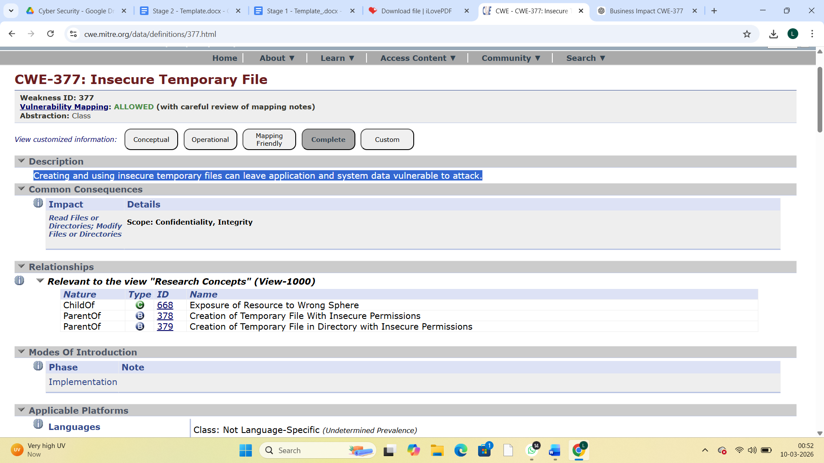

2)Vulnerability Name: Improper Restriction of XML External Entity Reference

CWE-611: Improper Restriction of XML External Entity Reference

OWASP Category: A02:2025 Security Misconfiguration

Description: The product processes an XML document that can contain XML entities with URIs that resolve to documents outside of the intended sphere of control, causing the product to embed incorrect documents into its output.
Business Impact: This vulnerability can allow attackers to access sensitive files or internal system resources through malicious XML requests. As a result, confidential business information such as user data, system configuration files, or database details may be exposed without authorization.
From a business perspective, such exposure can lead to serious data breaches and loss of sensitive organizational information. If attackers gain access to internal systems, it may also disrupt business operations, compromise system integrity, and create additional security risks.

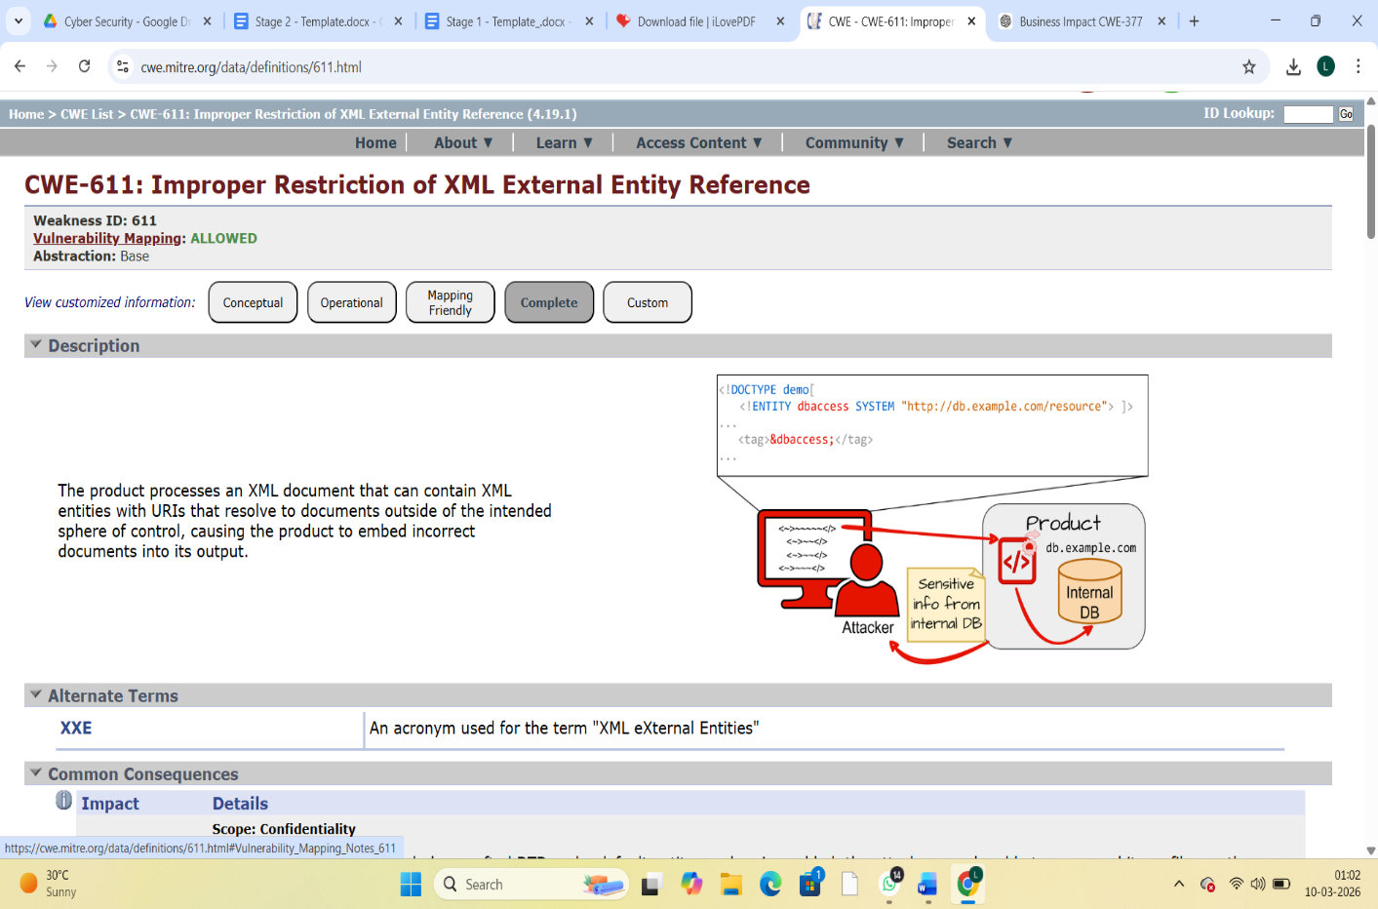
3)Vulnerability Name: Unimplemented or Unsupported Feature in UI
CWE-447: Unimplemented or Unsupported Feature in UI
OWASP Category: A03:2025 Software Supply Chain Failures

Description: A UI function for a security feature appears to be supported and gives feedback to the user that suggests that it is supported, but the underlying functionality is not implemented.

Business Impact: When a security feature appears to be available in the user interface but is not actually implemented in the system, users may believe that their data or actions are protected when they are not. This false sense of security can lead to sensitive information being handled without proper protection.
From a business perspective, this vulnerability can result in security gaps that attackers may exploit, potentially leading to unauthorized access, data exposure, or misuse of system functions. If users discover that the advertised security features do not work as expected, it can significantly damage the organization’s credibility and reduce customer trust.

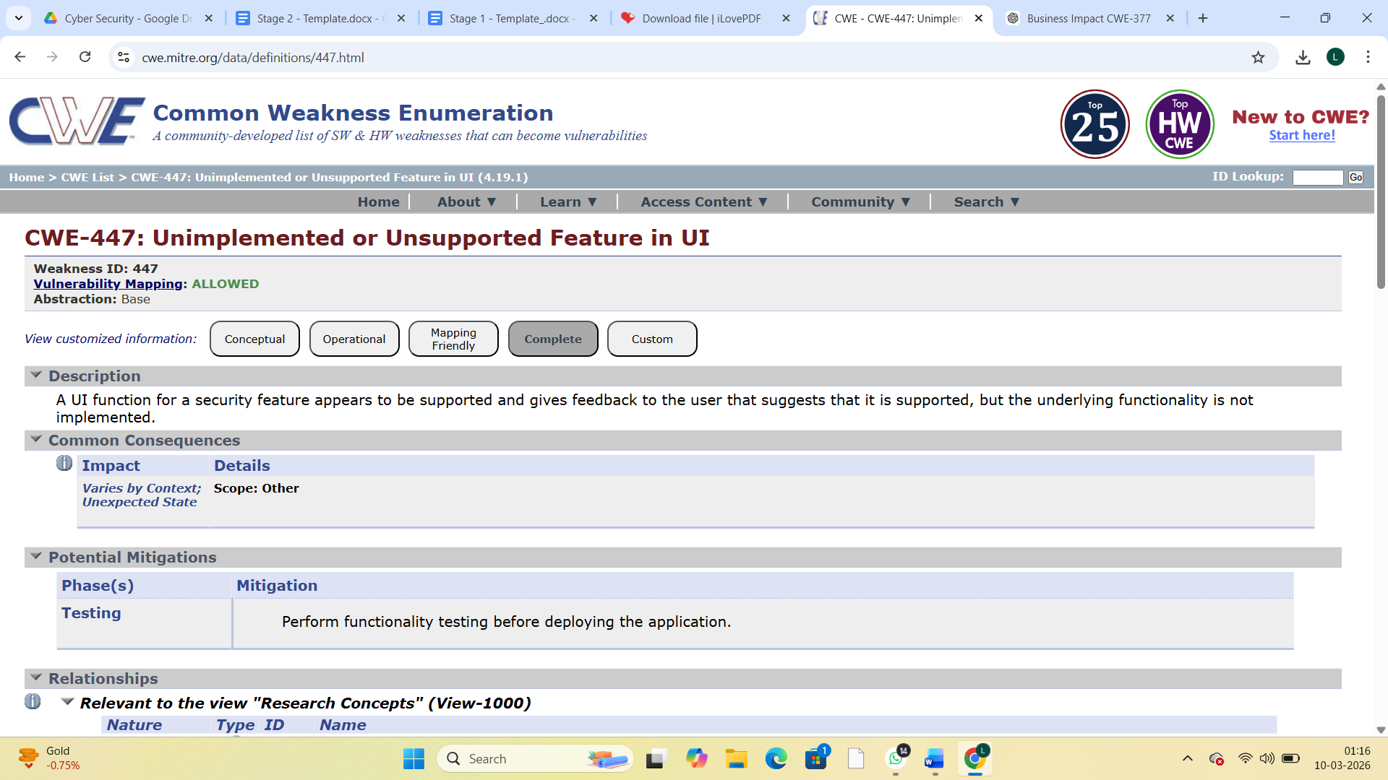

Vulnerability Name: Use of a One-Way Hash without a Salt

CWE-759: Use of a One-Way Hash without a Salt
OWASP Category: A04:2025 Cryptographic Failures

Description: The product uses a one-way cryptographic hash against an input that should not be reversible, such as a password, but the product does not also use a salt as part of the input.
Business Impact: When passwords are stored using a one-way hash without a salt, attackers can use precomputed tables such as rainbow tables to easily crack the hashed passwords. This significantly reduces the security of stored credentials and increases the risk of unauthorized account access.
From a business perspective, compromised user accounts can lead to data breaches, exposure of sensitive information, and misuse of system resources. Such incidents may damage the organization’s reputation, reduce customer trust, and result in legal or financial consequences due to security and compliance violations.

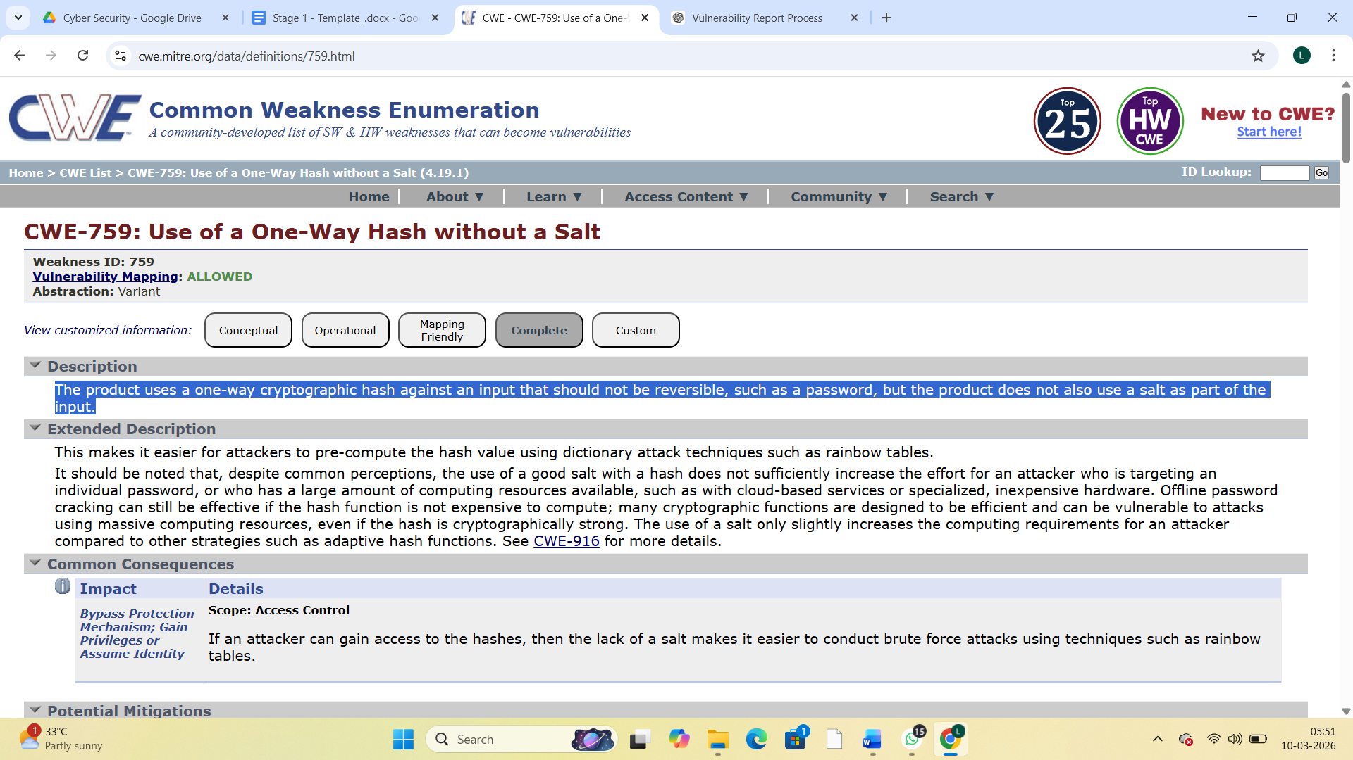

- Vulnerability Name: Process Control
CWE-114: Process Control
OWASP Category: A05:2025 Injection

Description: Executing commands or loading libraries from an untrusted source or in an untrusted environment can cause an application to execute malicious commands (and payloads) on behalf of an attacker.
Business Impact: Improper process control can allow attackers to execute malicious code through untrusted libraries or commands. This may lead to unauthorized system access, data breaches, and disruption of application services. As a result, organizations may face financial losses, operational downtime, and security incidents. It can also damage the organization’s reputation and reduce customer trust.

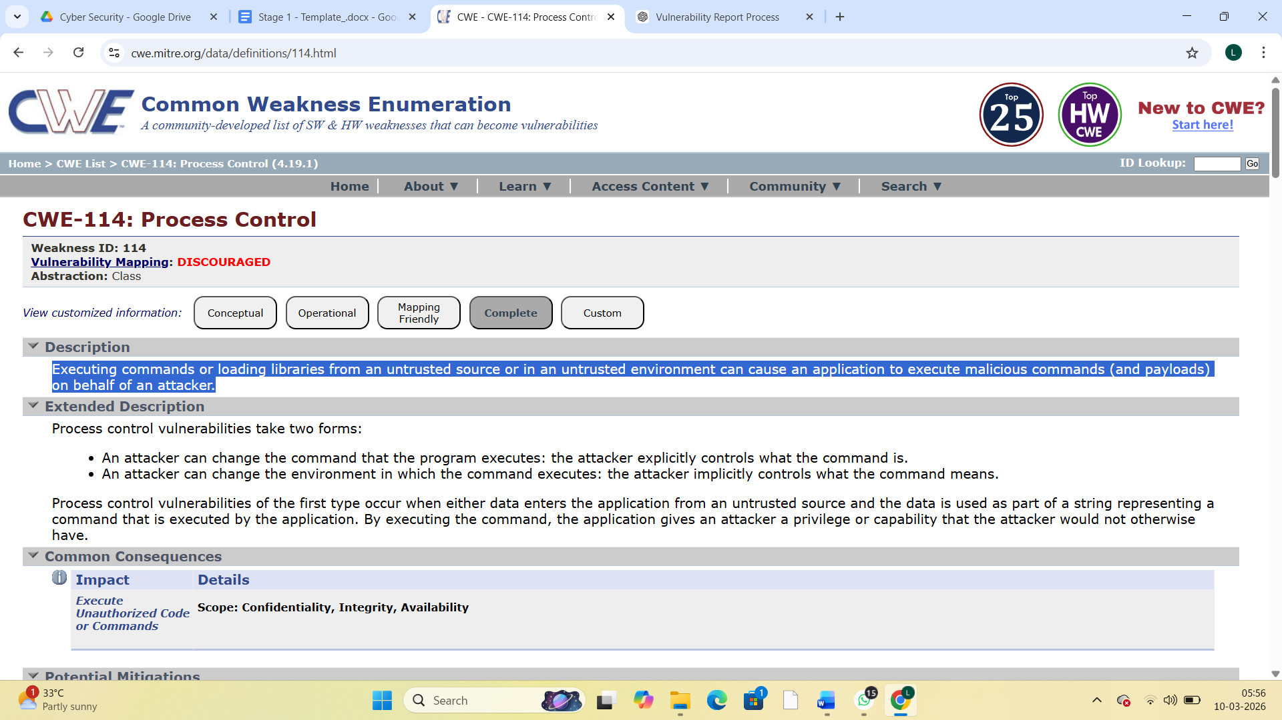
- Vulnerability Name: Attack Surface

CWE-1125: Excessive Attack Surface

OWASP Category: A06:2025 Insecure Design

Description: The product has an attack surface whose quantitative measurement exceeds a desirable maximum.
Business Impact: When an application exposes too many entry points, services, or unnecessary functionalities, it increases the opportunities for attackers to find and exploit security weaknesses. A larger attack surface makes it easier for attackers to identify vulnerabilities and gain unauthorized access to the system.
From a business perspective, this can lead to data breaches, service disruptions, and exploitation of system components. As a result, organizations may experience financial losses, operational downtime, regulatory penalties, and damage to their reputation and customer trust.


- Vulnerability Name: Incorrectly Specified Destination in a Communication Channel

CWE-941: Incorrectly Specified Destination in a Communication Channel

OWASP Category: A07:2025 Authentication Failures

Description: The product creates a communication channel to initiate an outgoing request to an actor, but it does not correctly specify the intended destination for that actor.

Business Impact: If a communication channel does not correctly specify the intended destination, requests may be sent to an unintended or malicious actor. Attackers may intercept, redirect, or manipulate the communication to gain unauthorized access to sensitive information. From a business perspective, this vulnerability can lead to data leakage, unauthorized transactions, or misuse of system resources. Such incidents may result in financial losses, operational disruptions, regulatory issues, and damage to the organization’s reputation and customer trust.

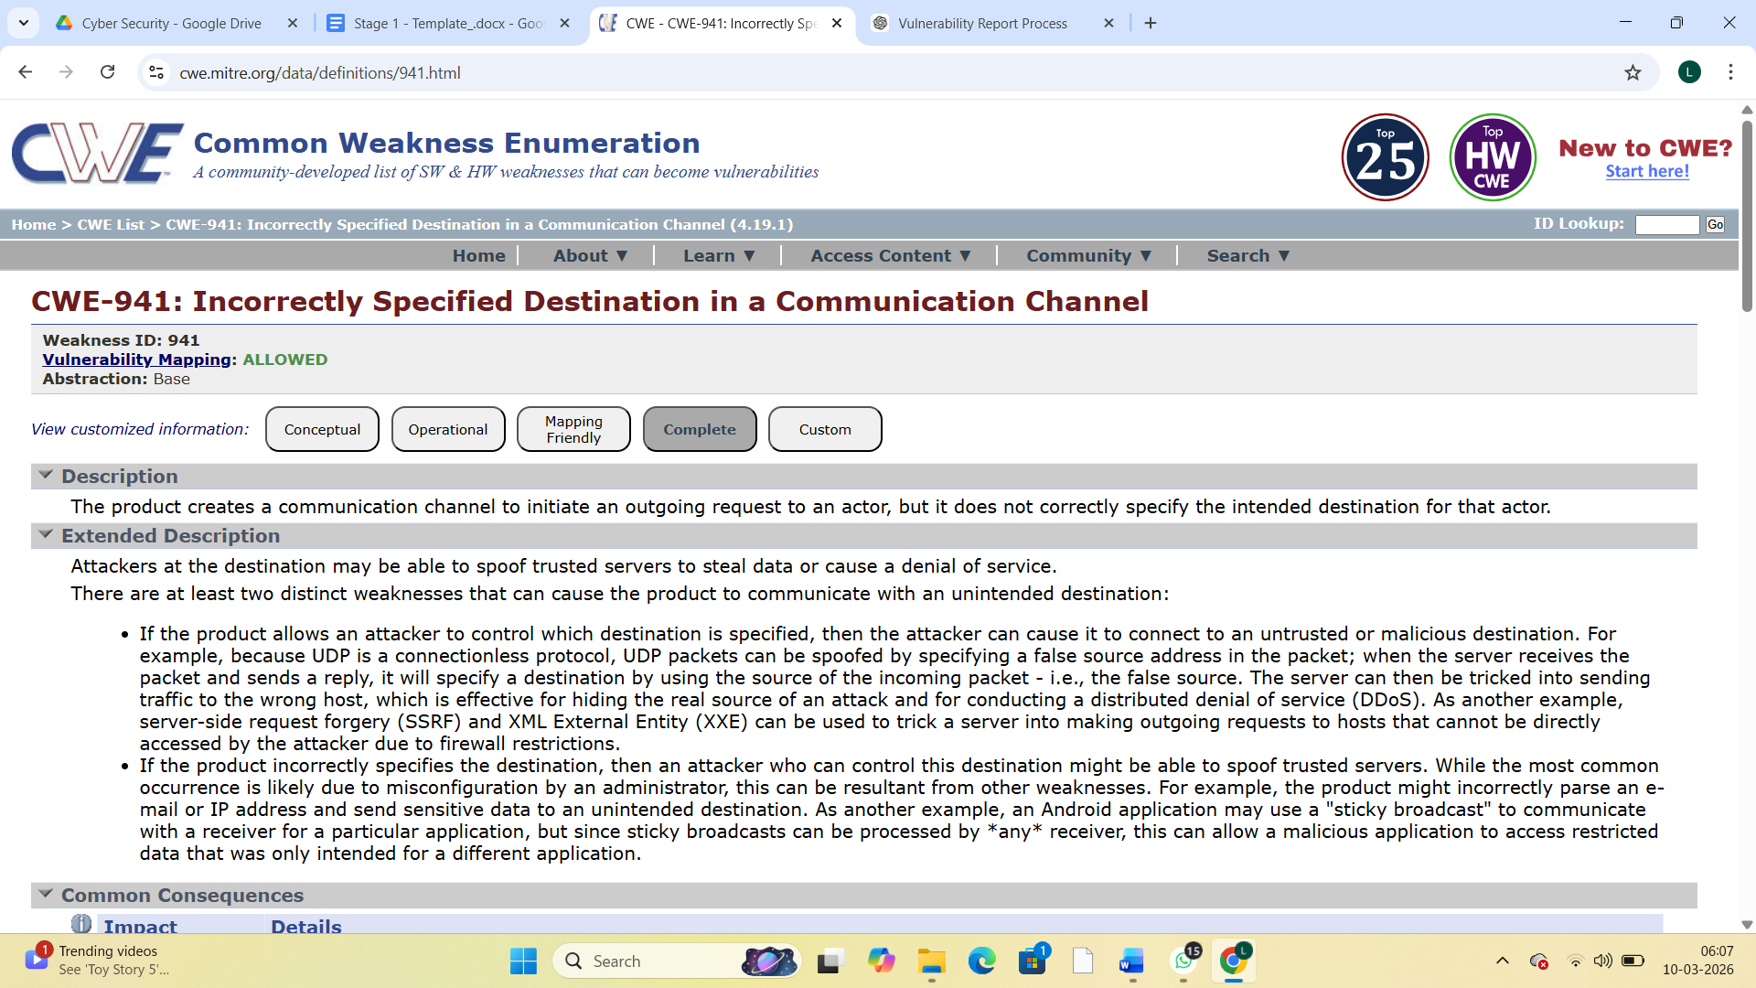

- Vulnerability Name: Embedded Malicious Code
CWE-506: Embedded Malicious Code
OWASP Category: A08:2025 Software or Data Integrity Failures
Description: The product contains code that appears to be malicious in nature.

Business Impact: If malicious code is embedded within an application, it can allow attackers to perform unauthorized actions such as stealing sensitive data, modifying system behavior, or creating backdoors for future attacks. This can compromise the integrity and security of the entire system.
From a business perspective, the presence of malicious code may lead to data breaches, system compromise, and disruption of business operations. It can also result in financial losses, legal liabilities, and serious damage to the organization’s reputation and customer trust.

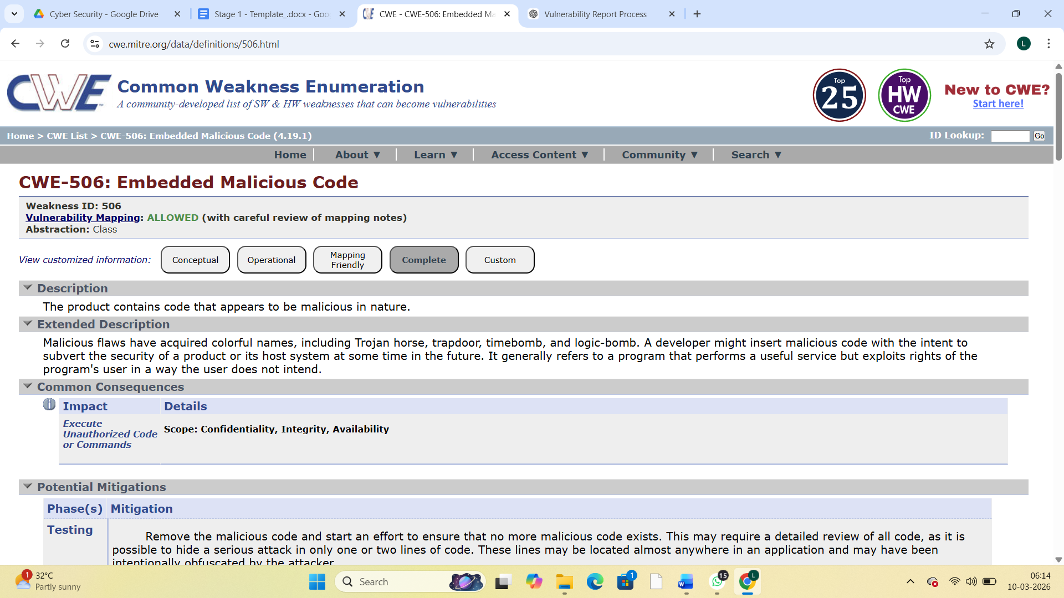

- vulnerability Name: Information Loss or Omission

CWE-221: Information Loss or Omission

OWASP Category: A09:2025 Security Logging & Alerting Failures

Description: The product does not record, or improperly records, security-relevant information that leads to an incorrect decision or hampers later analysis.
Business Impact: If security-related information is not properly recorded or is missing, it becomes difficult to detect, investigate, and respond to security incidents. Attackers may exploit system weaknesses without being noticed, allowing malicious activities to continue undetected.
From a business perspective, this can lead to delayed incident response, data breaches, and operational disruptions. It may also result in compliance violations, financial losses, and damage to the organization’s reputation and customer trust.
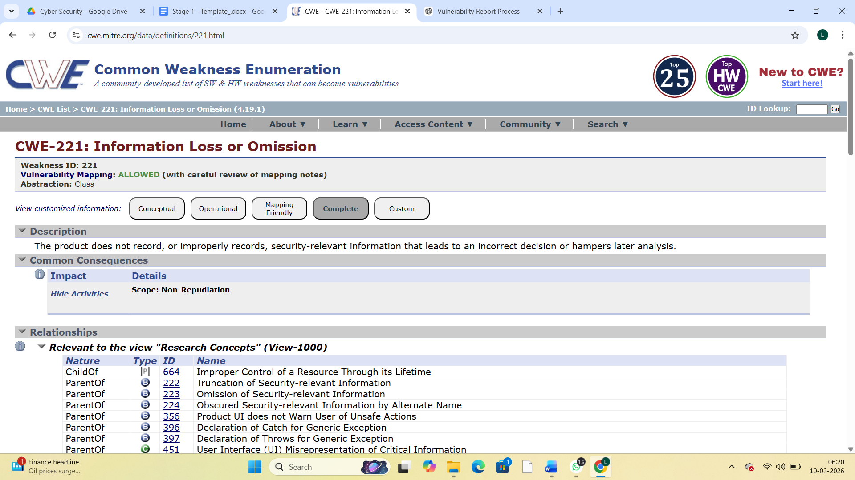

- Vulnerability Name: NULL Pointer Dereference
CWE-476: NULL Pointer Dereference
OWASP Category: A10:2025 Mishandling of Exceptional Conditions

Description: The product dereferences a pointer that it expects to be valid but is NULL.
Business Impact: A NULL pointer dereference can cause an application to crash or behave unexpectedly when it attempts to access an invalid memory location. This may lead to system instability and interruption of application services. From a business perspective, such failures can result in application downtime, loss of availability, and disruption of normal business operations. Frequent crashes may also affect user experience, reduce customer trust, and potentially lead to financial losses due to service interruptions.

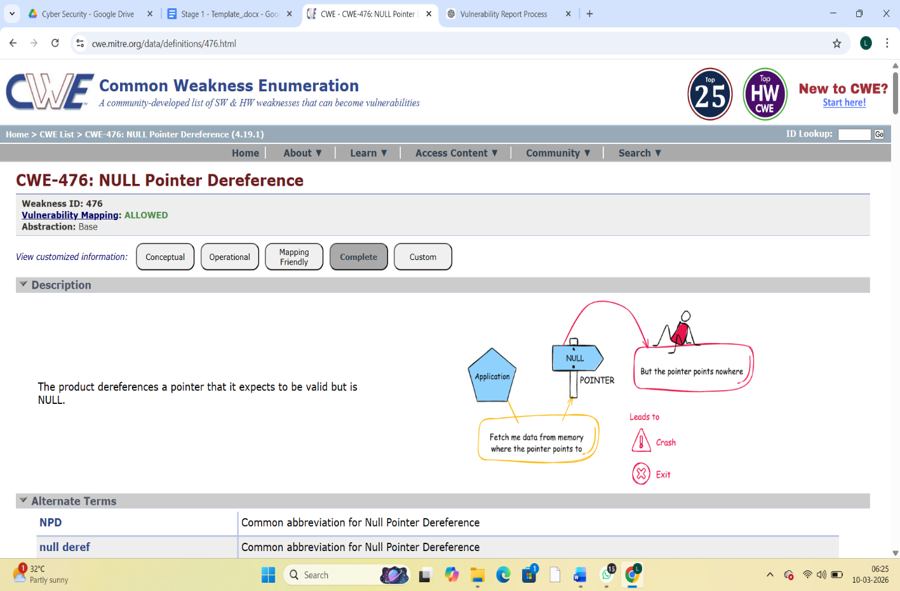

Stage 2

Overview :-

Nessus is a vulnerability scanner developed by Tenable, Inc. It is a remote scanner, meaning that it does not need to be installed on the target host to scan it. Nessus works by sending a variety of probes to the target host in order to identify vulnerabilities. These probes can include network traffic, operating system commands, and application requests.

Nessus uses a plugin-based architecture. Plugins are small pieces of code that are designed to identify specific vulnerabilities. There are over 1200 plugins available for Nessus, covering a wide range of vulnerabilities in operating systems, applications, and network devices.

When Nessus scans a host, it first uses a discovery plugin to identify the operating system and services running on the host. Once the host has been discovered, Nessus runs a series of plugins to test for vulnerabilities. For each vulnerability that Nessus finds, it provides a detailed report that includes the severity of the vulnerability, the steps to reproduce the vulnerability, and the steps to remediate the vulnerability.

Nessus can be used to scan a variety of targets, including single hosts, networks, and web applications. It can also be used to scan specific ports and services. Nessus can be configured to run scans on a schedule or manually.

Here is a step-by-step explanation of how Nessus works:

- Nessus connects to the target host using a variety of protocols, including TCP, UDP, and ICMP.
- Nessus sends a series of probes to the target host in order to identify its operating system and services.
- Nessus runs a series of plugins to test for vulnerabilities.
- Nessus generates a report that includes the severity of each vulnerability, the steps to reproduce the vulnerability, and the steps to remediate the vulnerability.

Nessus is a valuable tool for security professionals who need to identify and remediate vulnerabilities in their networks. It is easy to use and provides comprehensive reports that can be used to prioritise remediation efforts.

Here are some of the benefits of using Nessus:

  - Comprehensive vulnerability coverage: Nessus has over 1200 plugins available, covering a wide range of vulnerabilities in operating systems, applications, and network devices.
  - Easy to use: Nessus has a user-friendly interface that makes it easy to configure and run scans.
  - Comprehensive reporting: Nessus provides detailed reports that include the severity of each vulnerability,the steps to reproduce the vulnerability, and the steps to remediate the vulnerability.
  - Scalability: Nessus can be used to scan a variety of targets, including single hosts, networks, and web applications.
  - Flexibility: Nessus can be configured to run scans on a schedule or manually.

Nessus is a powerful tool that can be used to improve the security of any network. It is a valuable asset for any security professional.

List of vulnerability:-

s.no | Vulnerability name | Severity | plugins
1 | TLS Version 1.0 Protocol  Detection | MEDIUM | 104743
2 | TLS Version 1.1 Protocol  Deprecated | MEDIUM | 157288
3 | SSL/TLS Diffie-Hellman Modulus  <= 1024 Bits (Logjam) | LOW | 83875
4 | ICMP Timestamp Request Remote  Date Disclosure | INFO | 10114
5 | Additional DNS Hostnames | INFO | 46180
6 | Apache Tomcat Detection | INFO | 39446
7 | Common Platform Enumeration  (CPE) | INFO | 45590
8 | Device Type | INFO | 54615
9 | HSTS Missing From HTTPS Server | INFO | 84502
10 | HTTP Server Type and Version | INFO | 10107

REPORT: -

- Vulnerability Name: - 104743 - TLS Version 1.0 Protocol Detection Severity: - MEDIUM
Plugin: - 104743

Port: - 443
Description: - The remote service accepts connections encrypted using TLS 1.0. TLS 1.0 has a number of cryptographic design flaws. Modern implementations of TLS 1.0 mitigate these problems, but newer versions of TLS like 1.2 and 1.3 are designed against these flaws and should be used whenever possible.

As of March 31, 2020, Endpoints that aren’t enabled for TLS 1.2 and higher will no longer function properly with major web browsers and major vendors.
PCI DSS v3.2 requires that TLS 1.0 be disabled entirely by June 30, 2018, except for POS POI terminals (and the SSL/TLS termination points to which they connect) that can be verified as not being susceptible to any known exploits.
Solution: - Enable support for TLS 1.2 and 1.3, and disable support for TLS 1.0.
Business Impact: -Continued use of TLS 1.0's encryption, known for its inherent cryptographic flaws, exposes the organization to heightened security risks, increasing the likelihood of data breaches and cyberattacks. This vulnerability jeopardizes compliance with industry standards, specifically PCI DSS v3.2, which mandates the complete cessation of TLS 1.0 use. Non- compliance risks regulatory penalties and erodes customer trust. Moreover, endpoints that lack support for TLS 1.2 and higher will experience impaired functionality with major web browsers and vendors, potentially leading to lost business opportunities and damage to the organization's reputation. Addressing this vulnerability is imperative to mitigate these multifaceted risks and maintain a secure and trustworthy online presence.

Vulnerability Name: - 157288 - TLS Version 1.1 Protocol Deprecated Severity: - MEDIUM
Plugin: - 157288

Port: - 443
Description: - The remote service accepts connections encrypted using TLS 1.1. TLS 1.1 lacks support for current and recommended cipher suites. Ciphers that support encryption before MAC computation, and authenticated encryption modes such as GCM cannot be used with TLS 1.1 As of March 31, 2020, Endpoints that are not enabled for TLS 1.2 and higher will no longer function properly with major web browsers and major vendors.
Solution: - Enable support for TLS 1.2 and/or 1.3, and disable support for TLS 1.1.

Business Impact: -The continued use of TLS 1.1 with its lack of support for modern cipher suites and advanced encryption methods jeopardizes the organization's security posture, increasing vulnerability to cyber threats and potential data breaches. Additionally, endpoints not upgraded to support TLS 1.2 and higher will encounter compatibility issues with major web browsers and vendors, impacting user experience and potentially leading to missed business opportunities. Swift remediation of this vulnerability is essential to mitigate security risks and ensure seamless interactions with web browsers and vendors, preserving the organization's reputation and operational efficiency.

Vulnerability Name: - 83875 - SSL/TLS Diffie-Hellman Modulus <= 1024 Bits (Logjam) Severity: - LOW
Plugin: - 83875

Port: - 443
Description: - The remote host allows SSL/TLS connections with one or more Diffie-Hellman moduli less than or equal to 1024 bits. Through cryptanalysis, a third party may be able to find the shared secret in a short amount of time (depending on modulus size and attacker resources). This may allow an attacker to recover the plaintext or potentially violate the integrity of connections.
Solution: - Reconfigure the service to use a unique Diffie-Hellman moduli of 2048 bits or greater.
Business Impact: - Allowing SSL/TLS connections with weak Diffie-Hellman moduli raises security concerns. An attacker with sufficient resources and computing power could compromise the shared secret relatively quickly, potentially leading to the decryption of sensitive data or the violation of connection integrity. While the severity is low, the risk of data breaches and integrity compromise should not be underestimated, and it is essential to address this vulnerability to maintain data security and user trust.

Vulnerability Name: - 10114 - ICMP Timestamp Request Remote Date Disclosure Severity: - INFO
Plugin: - 10114

Port: - 0
Description: - The remote host answers to an ICMP timestamp request. This allows an attacker to know the date that is set on the targeted machine, which may assist an unauthenticated, remote attacker in defeating time-based authentication protocols.
Timestamps returned from machines running Windows Vista / 7 / 2008 / 2008 R2 are deliberately incorrect, but usually within 1000 seconds of the actual system time.
Solution: - Filter out the ICMP timestamp requests (13), and the outgoing ICMP timestamp replies (14).
Business Impact: -This does not pose an immediate threat to business operations or data security. This vulnerability allows external parties to request the system's date and time information remotely. While it does not present a significant risk, it could potentially be used by attackers for reconnaissance purposes. Therefore, it is advisable to address this vulnerability as part of a broader security posture to reduce the risk of unauthorized data gathering and protect against potential future threats.

Vulnerability Name: - 46180 - Additional DNS Hostnames Severity: - INFO
Plugin: - 46180

Port: - 0
Description: - Hostnames different from the current hostname have been collected by miscellaneous plugins. Nessus has generated a list of hostnames that point to the remote host. Note that these are only the alternate hostnames for hosts discovered on a web server.

Different web servers may be hosted on name-based virtual hosts.
Solution: - If you want to test them, re-scan using the special vhost syntax, such as : www.example.com [192.0.32.10]
Business Impact: -This does not pose an immediate threat to business operations or data security. It indicates the discovery of hostnames that are associated with the remote host, particularly in cases of web servers utilizing name-based virtual hosts. While not a security risk on its own, it could be useful for understanding the server's configuration and infrastructure.
Organizations should consider this information as part of their network documentation but do not need to take immediate action to mitigate it as a security threat.

Vulnerability Name: - 39446 - Apache Tomcat Detection Severity: - INFO
Plugin: - 39446

Port: - 80
Description: -Nessus was able to detect a remote Apache Tomcat web server.

Solution: - n/a
Business Impact: -Is an informational finding that identifies the presence of a remote Apache Tomcat web server. While this information itself does not indicate a security threat or impact on business operations, it can be useful for network administrators and security professionals to be aware of the technologies in use on their network. Understanding the presence of an Apache Tomcat server can be valuable for maintaining and securing web applications, but it does not require immediate action to mitigate a security risk.

Vulnerability Name: - 45590 - Common Platform Enumeration (CPE) Severity: - INFO
Plugin: - 45590

Port: - 0
Description: - By using information obtained from a Nessus scan, this plugin reports CPE (Common Platform Enumeration) matches for various hardware and software products found on a host.
Note that if an official CPE is not available for the product, this plugin computes the best possible CPE based on the information available from the scan.

Solution: - n/a
Business Impact: - This provides insights into hardware and software products identified on a host through a Nessus scan. It reports CPE matches, which are standardized identifiers for these products. This information is valuable for asset management and inventory purposes. While it doesn't signify a security threat, it aids administrators in understanding the components within their network, contributing to effective resource management and facilitating future system maintenance.

Vulnerability Name: - Device Type Severity: - INFO
Plugin: - 54615

Port: - 0
Description: - Based on the remote operating system, it is possible to determine what the remote system type is (eg: a printer, router, general-purpose computer, etc).

Solution: -
Business Impact: - It allows for the identification of the remote system type, such as a printer, router, or general-purpose computer, based on the remote operating system. While this doesn't pose a direct security threat, it offers valuable insights for network administrators to better understand and classify the devices in their network. This information aids in network

management, optimization, and ensures that the right security measures are in place for each device type.

Vulnerability Name: - 84502 - HSTS Missing From HTTPS Server Severity: - INFO
Plugin: - 84502

Port: - 443
Description: -The remote HTTPS server is not enforcing HTTP Strict Transport Security (HSTS). HSTS is an optional response header that can be configured on the server to instruct the browser to only communicate via HTTPS. The lack of HSTS allows downgrade attacks, SSL- stripping man-in-the-middle attacks, and weakens cookie-hijacking protections.
Solution: - Configure the remote web server to use HSTS.
Business Impact: -Indicates that the remote HTTPS server does not enforce HTTP Strict Transport Security (HSTS). HSTS is a crucial security feature that, when configured on the server, instructs web browsers to communicate exclusively via HTTPS, enhancing security. The absence of HSTS potentially exposes the server to downgrade attacks, SSL-stripping man-in-the- middle attacks, and weakens protections against cookie hijacking, posing risks to data confidentiality and user security. Enabling HSTS is essential to ensure a higher level of protection for data transmitted between clients and the server.

Vulnerability Name: - 10107 - HTTP Server Type and Version Severity: - INFO
Plugin: - 10107

Port: - 443

Description: - This plugin attempts to determine the type and the version of the remote web server.

Solution: - N/A
Business Impact: -This relates to the identification of the remote web server's type and version. While this issue doesn't pose an immediate security threat, it can provide valuable information to potential attackers about the server's software stack. Knowledge of the server type and version may aid attackers in exploiting known vulnerabilities specific to that software, making it important to restrict such information from being easily accessible to enhance the server's overall security posture.

Stage-3

Report :

Title: - Implementing Zero Trust Network Access (ZTNA) with Zscaler: Securing User-to-Application Connectivity

Topics Explored

This project focused on several important areas related to cybersecurity, threat intelligence, and modern network security practices. The study aimed to understand how different security technologies and processes work together to detect, analyse, and prevent cyber threats. Various stages of threat intelligence processing, security monitoring, and incident response were explored to gain a deeper understanding of modern cybersecurity frameworks.

Data Collection and Aggregation

One of the main aspects explored in this project is the process of collecting security data from multiple sources. In a modern network environment, information about threats can originate from several systems such as firewalls, intrusion detection systems, endpoint protection tools, and application logs.

Data collection and aggregation involve gathering these logs and security events into a centralized platform. This allows security teams to analyse large amounts of information efficiently and detect suspicious activities across the network. Aggregating data from multiple sources helps in identifying patterns that may not be visible when analysing individual systems separately.

This centralized data collection approach is especially important for Security Operations Centers (SOC), where analysts continuously monitor network activities to detect possible cyber threats.

Data Standardization and Normalisation

Once the data is collected from different sources, it often exists in various formats depending on the system that generated it. Therefore, standardization and normalization become essential steps in the security analysis process.

Standardization refers to converting data into a common format so that it can be easily understood and processed by security tools. Normalization ensures that information such as timestamps, IP addresses, event types, and user activities are structured consistently.

By performing these processes, organizations can ensure that security data can be analysed efficiently using automated tools and analytics systems. This improves the accuracy of threat detection and helps security teams identify unusual behaviour more effectively.

Data Enrichment and Analysis

After the collected data is normalized, the next step involves enriching the data with additional contextual information. Data enrichment enhances the quality of security data by adding extra details such as geographic location of IP addresses, domain reputation, threat intelligence information, and historical activity patterns.

This additional context helps security analysts understand the nature and severity of potential threats. For example, if a login attempt originates from a country known for cyber attacks, the system may flag the activity as suspicious.

Through detailed analysis of enriched data, organizations can detect malicious behaviour, unauthorized access attempts, and other potential cybersecurity risks.

Threat Intelligence Sharing and Distribution

Threat intelligence sharing plays a crucial role in improving global cybersecurity. Cyber threats often target multiple organizations using similar techniques. By sharing information about new vulnerabilities, malware signatures, malicious IP addresses, and phishing campaigns, organizations can strengthen their defense mechanisms.

Threat intelligence platforms enable security teams to distribute important threat information to other organizations and security communities. This collaborative approach helps organizations stay informed about emerging threats and respond quickly to potential attacks.

Through intelligence sharing, organizations can improve their ability to detect attacks early and implement preventive security measures.

Integration with Security Tools

Modern cybersecurity environments rely on the integration of various security tools and platforms. The project explored how threat intelligence systems integrate with tools such as vulnerability scanners, intrusion detection systems, SIEM platforms, and endpoint security solutions.

Integration allows these tools to exchange information and work together in a coordinated manner. For example, when a vulnerability scanner detects a critical security issue, the SIEM platform can immediately generate alerts and trigger automated responses.

This interconnected ecosystem enhances the overall effectiveness of cybersecurity operations and ensures faster detection and response to security incidents.

Customization and Flexibility in Security Systems

Another important aspect studied in this project is the flexibility and customization capabilities of modern security systems. Every organization has different security requirements depending on their network infrastructure, user base, and business operations.

Security platforms allow administrators to configure custom policies, rules, and monitoring parameters based on their organizational needs. This flexibility enables organizations to create tailored security strategies that align with their operational goals.

Customization also helps reduce false alarms by ensuring that alerts are generated only for genuinely suspicious activities.

Automation and Security Orchestration

Automation is becoming increasingly important in cybersecurity operations. With the growing number of cyber threats and security alerts, manual monitoring alone is no longer sufficient.

Automation tools can perform repetitive tasks such as log analysis, vulnerability scanning, and alert generation without human intervention. Security orchestration platforms can also automate incident response processes, enabling faster containment of cyber threats.

By implementing automation, organizations can improve the efficiency of their security operations while reducing the workload on security analysts.

Community Collaboration in Cybersecurity

Cybersecurity is not only an organizational responsibility but also a collaborative effort across the global security community. The project emphasized the importance of community participation in strengthening cybersecurity defenses.

Security researchers, organizations, and government agencies often collaborate by sharing threat intelligence, research findings, and security best practices. Open-source platforms and security communities provide valuable resources for identifying emerging cyber threats and developing effective mitigation strategies.

Such collaboration helps organizations stay updated about the latest attack techniques and defense mechanisms.

Incident Response Support

Effective incident response is essential for minimizing the impact of cyber attacks. The project explored how threat intelligence platforms support incident response by providing detailed information about suspicious activities and security incidents.

When a security breach occurs, incident response teams analyse logs, identify the source of the attack, and implement appropriate containment measures. Threat intelligence tools help analysts investigate the incident by providing insights into known malware signatures, malicious IP addresses, and attack patterns.

This information enables faster detection, investigation, and resolution of cybersecurity incidents.

Role of SOC and SIEM

Security Operations Centers (SOC) and Security Information and Event Management (SIEM) systems play a vital role in monitoring and managing cybersecurity operations.

A SOC is responsible for continuously monitoring network activities, identifying security threats, and responding to incidents. SIEM platforms collect and analyse log data from various network devices and applications to detect suspicious activities.

By combining SOC operations with SIEM technology, organizations can achieve real-time threat detection, improved visibility, and faster response to cyber attacks.

Tools Explored

During the course of this project, several cybersecurity tools were studied and used to understand different aspects of network security, vulnerability assessment, and penetration testing.

Nmap

Nmap is a widely used network scanning tool that helps security professionals discover devices connected to a network. It can identify open ports, running services, and operating systems on target machines.

Security analysts use Nmap to perform network discovery and identify potential vulnerabilities in systems. It is commonly used during penetration testing to map the network structure and detect possible entry points for attackers.

Metasploit

Metasploit is a powerful penetration testing framework used to identify and exploit vulnerabilities in systems. It contains a large collection of exploit modules that allow security researchers to simulate cyber attacks in a controlled environment.

By using Metasploit, security professionals can test the security of applications and systems, identify weaknesses, and implement appropriate security patches.

Nessus

Nessus is a popular vulnerability scanning tool used to detect security weaknesses in networks, operating systems, and applications. It performs automated scans to identify misconfigurations, outdated software, and known vulnerabilities.

The tool generates detailed reports that help organizations understand potential security risks and take corrective actions to strengthen their security infrastructure.

Kali Linux

Kali Linux is a specialized operating system designed for cybersecurity professionals and penetration testers. It includes a wide range of security tools used for network analysis, vulnerability scanning, and digital forensics.

Kali Linux provides a comprehensive environment for conducting security testing and research activities.

OWASP ZAP

OWASP ZAP is an open-source web application security scanner developed by the OWASP community. It is used to detect vulnerabilities in web applications such as SQL injection, cross-site scripting (XSS), and other security flaws.

Security testers use OWASP ZAP to analyse web application behaviour and identify potential security risks during the development and testing phases.

Burp Suite

Burp Suite is a widely used web application security testing platform. It allows security analysts to intercept and analyse HTTP requests and responses between a user and a web application.

With Burp Suite, testers can identify vulnerabilities, manipulate web traffic, and perform detailed security analysis to improve application security.

Future Scope: -

Future of web application testing

The future of WAT is bright, as web applications become increasingly complex and sophisticated. Organizations are increasingly reliant on web applications to conduct business, and they need to be confident that their web applications are secure and reliable.

Here are some of the key trends that are expected to shape the future of WAT:

- Increased focus on security: Security is a top priority for all organizations, and WAT is essential for identifying and mitigating security vulnerabilities. In the future, we can expect to see even more emphasis on security testing, as web applications become increasingly targeted by cyberattacks.
- Rise of artificial intelligence (AI) and machine learning (ML): AI and ML are already being used in WAT, and their role is expected to grow in the future. AI and ML can be used to automate repetitive tasks, such as test case generation and execution. They can also be used to identify complex patterns and anomalies that may be difficult to detect with traditional testing methods.
- Shift to cloud-based testing: More and more organizations are moving their web applications to the cloud. This trend is driving the growth of cloud-based WAT platforms. Cloud-based testing platforms offer a number of advantages, such as scalability, flexibility, and cost-effectiveness.
- Increased focus on user experience (UX) testing: UX testing is essential for ensuring that web applications are easy to use and meet the needs of users. In the future, we can expect to see more focus on UX testing, as organizations increasingly recognize the importance of providing a positive user experience.

Tools explored: -

Nmap, Metasploit, Nessus, Kali Linux, OWASP ZAP, Burp Suite

THE END

